Here’s your **Datadog Synthetic Monitoring Lab Guide** without icons:

**Lab: Setting Up Datadog Synthetic Monitoring**

**Objective:**

* Configure Datadog Synthetic Monitoring to track website and API availability.
* Set up Browser Tests and API Tests in Datadog.
* Trigger alerts on failures.

**Pre-requisites**

* Datadog Account – Sign up at [Datadog](https://app.datadoghq.com/signup/).
* Datadog API Key – Available in your Datadog dashboard under **Integrations → APIs**.
* Ubuntu Machine with Docker installed (for local API testing).
* A Publicly Accessible Website or API (e.g., https://example.com).

**Step 1: Install Datadog Agent on Ubuntu**

1. Update system packages
2. sudo apt update && sudo apt install -y curl
3. Download & install the Datadog agent
4. DD_AGENT_MAJOR_VERSION=7 DD_API_KEY=<YOUR_DATADOG_API_KEY> DD_SITE="datadoghq.com" bash -c "$(curl -L https://s3.amazonaws.com/dd-agent/scripts/install_script.sh)"

Replace <YOUR_DATADOG_API_KEY> with your actual API key.

1. Verify installation
2. sudo systemctl status datadog-agent

If the agent is running, proceed to the next step.

**Step 2: Enable Synthetic Monitoring in Datadog**

1. Log into Datadog.
2. Go to **Synthetic Monitoring** in the Datadog dashboard.
3. Click on **Create a New Test**.

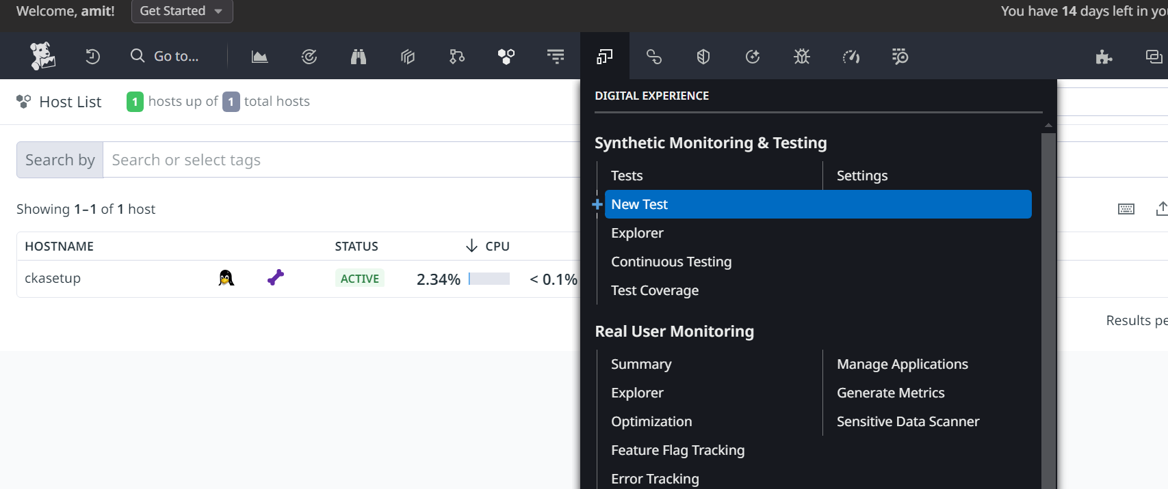

1. Choose Test Type:
   * **Browser Test** (for UI simulation)
   * **API Test** (for endpoint monitoring)

**Step 3: Create a Browser Test (Website Monitoring)**

1. Go to Synthetic Monitoring → Create a New Test.
2. Select **Browser Test**.
3. Enter the URL to monitor (e.g., <https://example.com>).

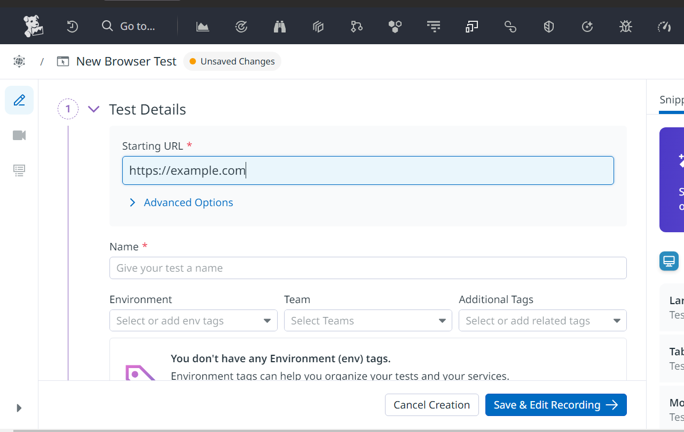

1. Add Test Steps (Optional):
   * Click on buttons, log in, fill out forms, etc.
2. Select Locations & Frequency:
   * Choose multiple global locations (e.g., US, Europe, Asia).
   * Set test frequency (e.g., every 5 minutes).
3. Set Up Alerts:
   * Alert if page load time exceeds 3 seconds.
   * Alert if response contains error codes (e.g., 500, 404).
4. Click **Run Test** & Save.

**Step 4: Create an API Test (API Monitoring)**

1. Go to Synthetic Monitoring → Create a New Test.
2. Select **API Test**.
3. Enter API Endpoint URL (e.g., https://api.example.com/health).
4. Set HTTP Method & Headers:
   * Method: GET
   * Header: Authorization: Bearer <TOKEN> (if authentication is required)
5. Define Test Assertions:
   * Status Code = 200 (Success)
   * Response Time < 2s
6. Set Monitoring Locations & Frequency:
   * Choose global locations (US, EU, Asia).
   * Run every 5 minutes.
7. Configure Alerts:
   * Alert if API returns 500 errors.
   * Alert if response time exceeds 2 seconds.
8. Click **Run Test** & Save.

**Step 5: Enable Alerting & Notifications**

1. Go to Datadog → Integrations → Notifications.
2. Add Slack, Email, or PagerDuty.
3. Set Up an Alert Rule:
   * Condition: If the test fails more than three times in a row.
   * Notify: Slack, PagerDuty, or email.
4. Save the Alert Policy.

**Step 6: Validate & Monitor**

* Check **Synthetic Test Results** in the Datadog Dashboard.
* Simulate a failure by shutting down the API or website to see if alerts are triggered.
* Optimize response times based on performance data.

**Lab Completion**

You have successfully:

* Installed the **Datadog Agent** on Ubuntu.
* Configured **Browser Monitoring** for a website.
* Set up **API Monitoring** with alerts.
* Enabled **global monitoring** and **failure notifications**.

Would you like a Terraform or Ansible automation script to deploy this setup? Let me know how I can assist further.